**UNIVERSITY OF BUEA**

**\*\*\*\*\*\*\*\*\*\*\*\*\*\*\*\*\*\*\*\*\*\*\*\*\*\*\*\*\*\*\*\*\*\***

**FACULTY OF ENGINEERING AND TECHNOLOGY**

**\*\*\*\*\*\*\*\*\*\*\*\*\*\*\*\*\*\*\*\*\*\*\*\*\*\*\*\*\***

**DEPARTMENT OF COMPUTER ENGINEERING**

**\*\*\*\*\*\*\*\*\*\*\*\*\*\*\*\*\*\*\*\*\*\*\*\***

**CEF 440: MOBILE PROGRAMMING**

**LEVEL 400: 2022/2023 ACADEMIC YEAR**

**Project Title:**

**DESIGN AND IMPLEMENTATION OF A PASSENGER POSITIONING SYSTEM**

**TASKS 4:**

**SYSTEM DESIGN DIAGRAMS**

**Supervisor:**

**DR NKEMENI VALERY**

**Group 8 Members:**

|  |  |
| --- | --- |
| **NGI KEVIN AYUK** | **FE20A076** |
| **NDEM LARRY NCHENY** | **FE20A071** |
| **TASHA OLIVIA** | **FE20A0112** |
| **TAGHA WILFRED** | **FE20A0122** |
| **A. CLINTON MBURLI** | **FE20A010** |

Contents

INTRODUCTION 3

Tools used for diagrams 3

USECASE DIAGRAM 3

SEQUENCE DIAGRAM 5

SIGN UP 5

RIDE REQUEST 6

VIEW PASSENGERS 7

VIEW HISTORY 7

CLASS DIAGRAM 8

Class Diagram 8

DATA FLOW DIAGRAM 9

ACTIVITY DIAGRAM 10

REFERENCES 11

# **INTRODUCTION**

This report presents the system design diagrams of our passenger positioning system. These diagrams include all the critical UML design diagrams that are essential to the design and development of our application. By using these diagrams together, we ensure that the system is well-structured, efficient, and meets the needs of our targeted users. Each diagram is presented on subsequent pages with its importance to our development cycle.

## Tools used for diagrams

-StarUML and Planttext.

# **USECASE DIAGRAM**

The use case diagram is an essential tool for defining the different scenarios in which the application will be used. It helps to identify the system's requirements and design the functionality to meet those requirements. The use case diagram is particularly important for understanding the interactions between users and the system, ensuring that the system meets the needs of its users. Our final use case diagram is shown below.

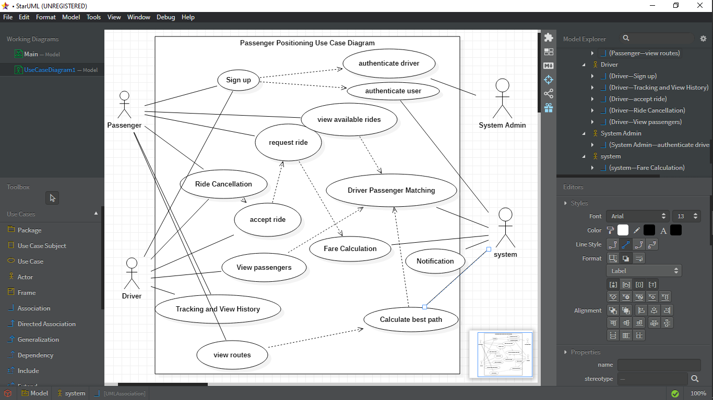

# **SEQUENCE DIAGRAM**

UML sequence diagrams are visual representations of interactions between objects in a system over time. They are important because they help identify potential issues and improve a system's design before implementation. They provide a clear and concise way to represent complex interactions, validate system logic, identify errors, and are easily understood by all stakeholders. Below are the sequence diagrams for the use cases to be implemented:

## SIGN UP

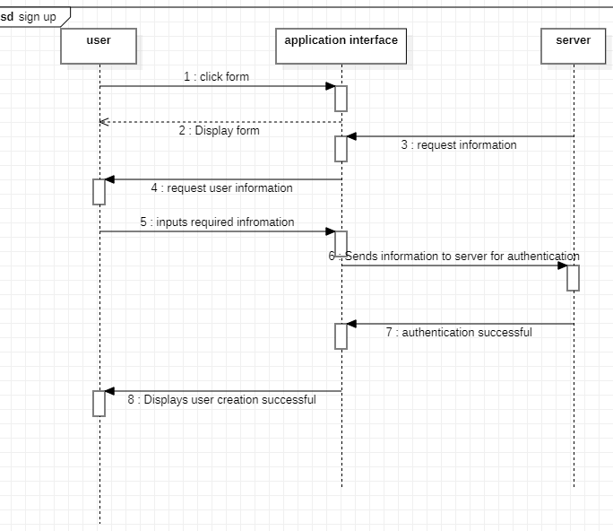

VIEW ROUTES

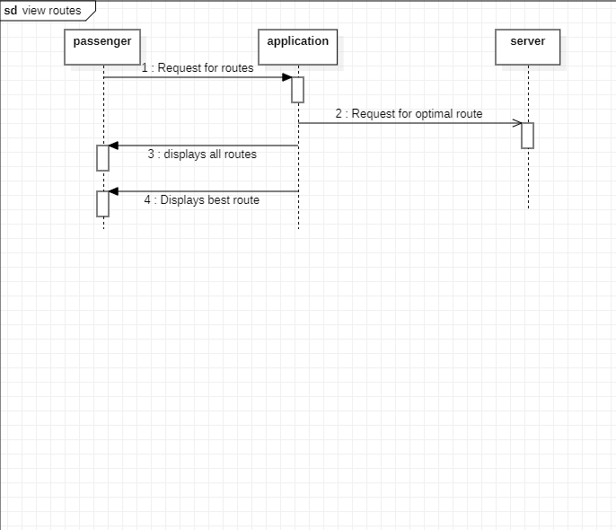

## RIDE REQUEST

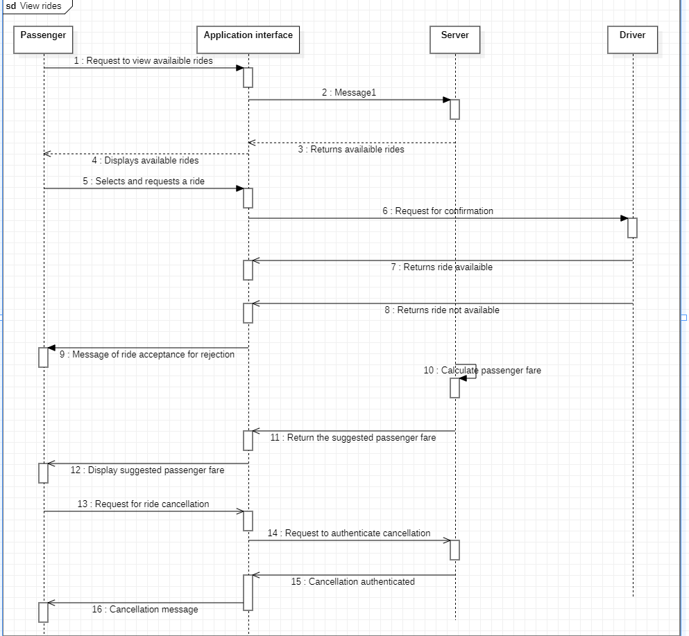

## VIEW PASSENGERS

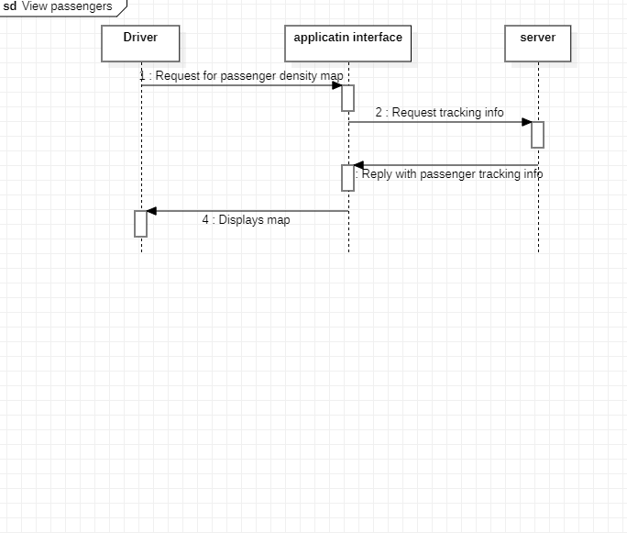

## VIEW HISTORY

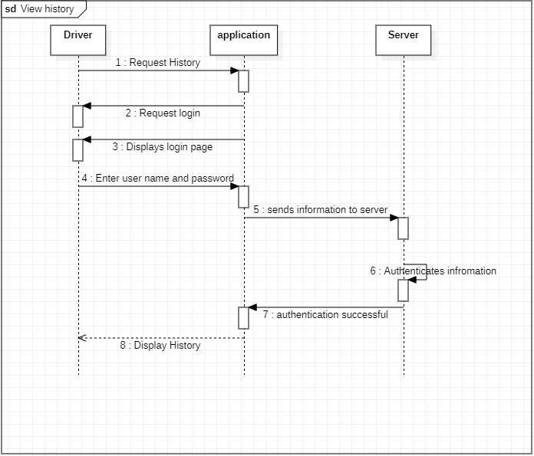

# **CLASS DIAGRAM**

The class diagram is a crucial component of the design and development of the Passenger Positioning System. It provides a visual representation of the different objects in the system, their attributes, methods, and relationships with other objects. This diagram is particularly important for ensuring that the system is well-structured, maintainable, and scalable.

## Class Diagram

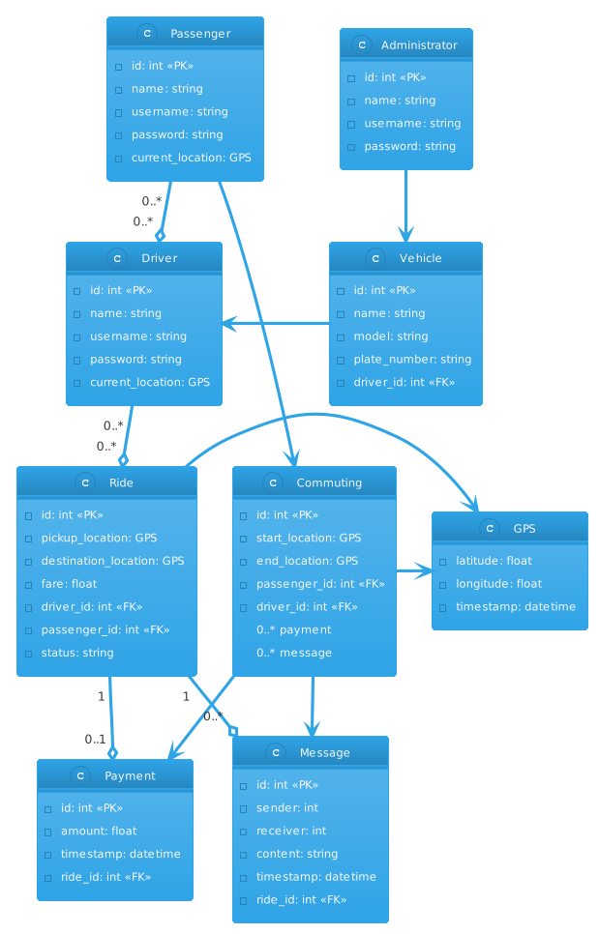

# **DATA FLOW DIAGRAM**

Data flow diagrams (DFDs) are diagrams that represent the flow of data through a system or process, showing inputs, outputs, and transformations. They were first introduced in structured analysis and design, and later became popular in systems analysis and data processing.

The importance of DFDs lies in their ability to help stakeholders understand how data moves through a system, identify potential bottlenecks or inefficiencies, and improve system design before implementation. They can be used in conjunction with other UML diagrams to provide a comprehensive view of a system's structure and behavior.

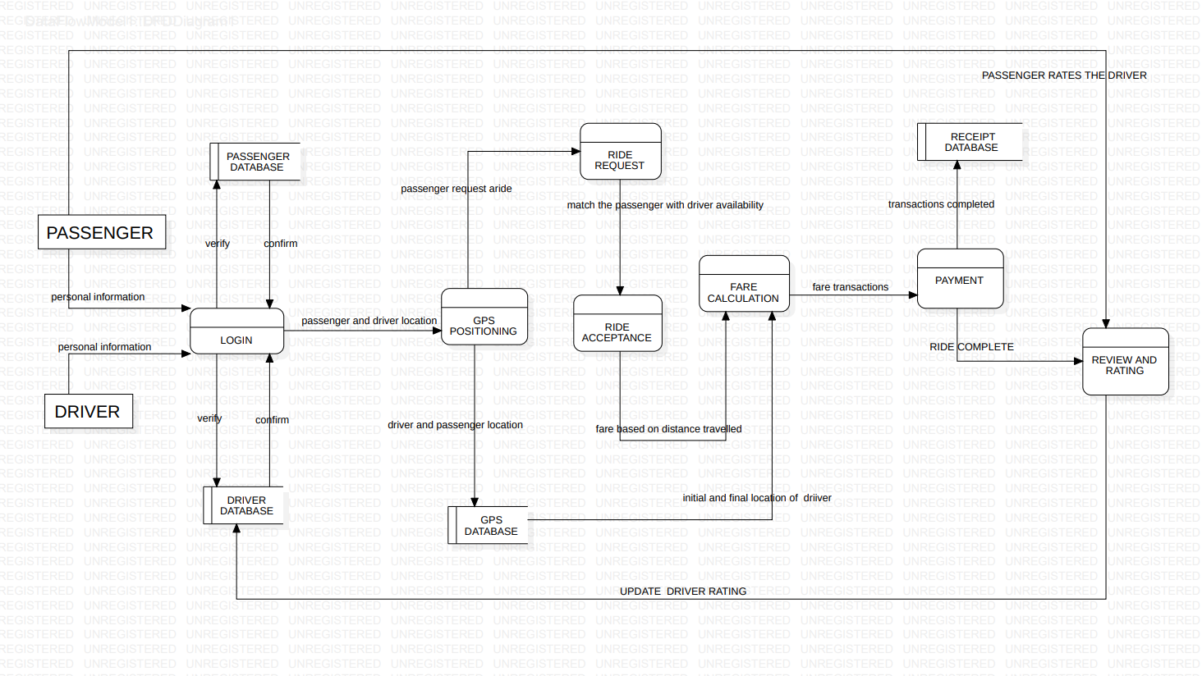

# **ACTIVITY DIAGRAM**

The activity diagram is an essential tool for understanding the dynamic behaviour of the Passenger Positioning System. It helps to visualize the different activities involved in a process and the order in which they occur. The activity diagram ensures that the system is well-designed and meets the needs of its users. It is also essential in communicating the dynamic behaviour of the system to other developers, stakeholders, and technical documentation.

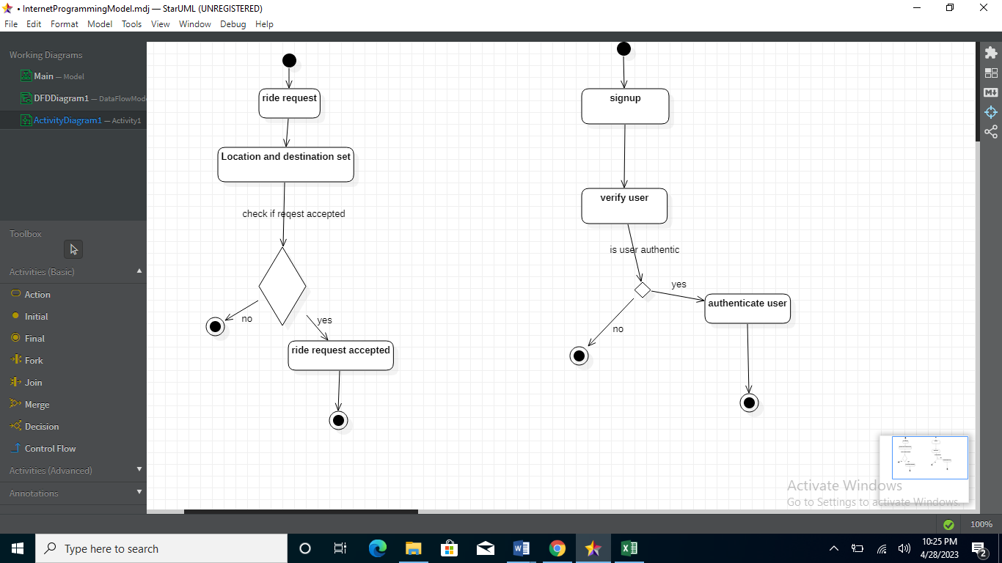

# REFERENCES

1. Summerville, I. (2011). Software engineering (9th ed.). Boston, MA: Addison-Wesley.
2. Fowler, Martin. "UML Distilled: A Brief Guide to the Standard Object Modeling Language."
3. Booch, Grady, Rumbaugh, James, and Jacobson, Ivar. "The Unified Modeling Language User Guide.